**Cycle -1(exp-3)**

1. Input a line of text and display it on standard output



1. Declare a variable and echo its value. For example, declare a variable of x and assign value=10.

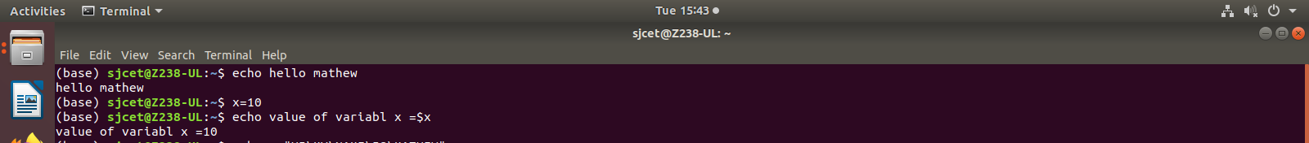

1. Using option ‘\b‘ – backspace with backslash interpretor ‘-e‘ which removes all the spaces in between.



1. Using option ‘\n‘ – New line with backspace interpretor ‘-e‘ treats new line from where it is used.



1. Using option ‘\t‘ – horizontal tab with backspace interpretor ‘-e‘ to have horizontal tab spaces.



6.Using option ‘\v‘ – vertical tab with backspace interpretor ‘-e‘ to have vertical tab spaces.



7.Using option ‘\r‘ – carriage return with backspace interpretor ‘-e‘ to have specified carriage return in output.



**READ**

1 split the user input into different variables by adding multiple arguments

2 When the user input has more words than there are variables, the extra words are

assigned to the last provided variable:



